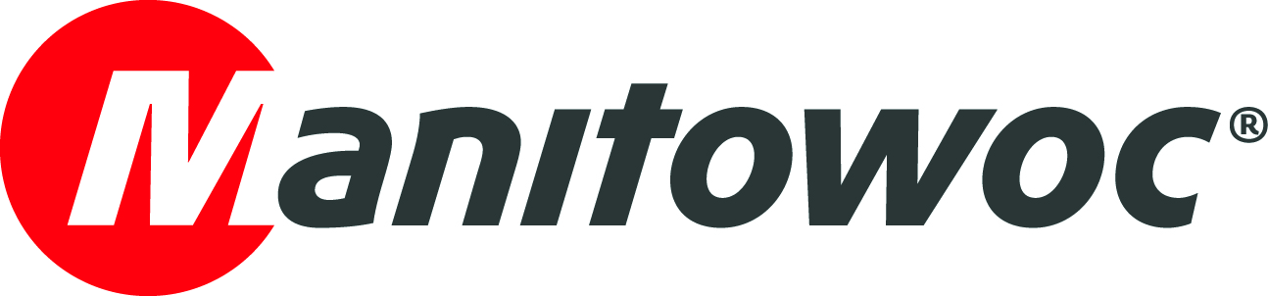
Caption Release

May xx, 2020

New Manitowoc MLC150-1 successfully completes structural testing
The new Manitowoc MLC150-1 crawler crane, announced last March at CONEXPO, has just passed a major milestone: it successfully completed its main boom structural testing at the company’s manufacturing facility in Shady Grove, Pennsylvania.
“We are very excited to continue to prove the performance of the MLC150-1 and get it into the field soon, so customers can start saving time and money with this crane,” said Andy Konkle, value stream director for crawler cranes at Manitowoc. “This new 150 t-capacity crane expands our portfolio of small crawler cranes. The first in the family was the MLC100-1, released in 2018, and it has proved to be extremely efficient and help customers deliver projects across the U.S. lucratively.”
Next, the MLC150-1 will begin fixed jib structural testing. The MLC150-1 will begin serial production in the end of 2020.
To learn more about the MLC150-1, click here.
-END-

CONTACT
Amy Marten
Manitowoc
T +1 920 683 6345
amy.marten@manitowoc.com

ABOUT THE MANITOWOC COMPANY, INC.
The Manitowoc Company, Inc. (“Manitowoc”) was founded in 1902 and has over a 117-year tradition of providing high-quality products and support services that are tailored to customers’ needs. Its 2019 net sales were approximately $1.83 billion. Manitowoc is one of the world's leading providers of engineered lifting solutions. Through its wholly-owned subsidiaries, Manitowoc designs, manufactures, markets and supports comprehensive product lines of mobile telescopic cranes, tower cranes, lattice-boom crawler cranes, boom trucks and industrial cranes under the Grove, Potain, Manitowoc, National Crane, Shuttlelift and Manitowoc Crane Care brand names.

THE MANITOWOC COMPANY, INC.
One Park Plaza – 11270 West Park Place – Suite 1000 – Milwaukee, WI 53224, USA
T +1 414 760 4600
www.manitowoc.com

